## **COMPONENTS** **USED**

* ARM CORTEX MICROCONTROLLER
* SOIL MOISTURE SENSOR
* LCD DISPLAY
* OPTO-COUPLER
* RELAY
* ZIGBEE MODULE
* GSM MODULE
* REAL TIME CLOCK
* USB
* SOLAR PANEL

## ARM CORTEX M0 LPC11U24:

**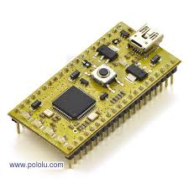**

ARM Cortex-M0

## **General description:**

* The LPC11U2x are an ARM Cortex-M0 based, low-cost 32-bit MCU family, designed for 8/16-bit microcontroller applications, offering performance, low power, simple instruction set and memory addressing together with reduced code size compared to existing 8/16-bit architectures.
* The LPC11U2x operate at CPU frequencies of up to 50 MHz
* Equipped with a highly flexible and configurable full -Speed USB 2.0 device controller, the LPC11U2x brings unparalleled design flexibility and seamless integration to today’s demanding connectivity solutions.
* The peripheral complement of the LPC11U2x includes up to 32 kB of flash memory, up to 10 kB of SRAM data memory and 4 kB EEPROM, one Fast -mode Plus I2C-bus interface, one RS-485/EIA-485 USART with support for synchronous mode and smart card interface, two SSP interfaces, four general- purpose counter/timers, a 10-bit ADC (Analogy-to-Digital Converter), and up to 54 general-purpose I/O pins.

## VH400 SOIL MOISTURE SENSOR:

**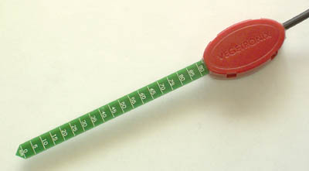**

VH400 Moisture sensor

High frequency VH400 series soil moisture sensor probes enable precise low cost monitoring of soil water content.  Because our probe measures the dielectric constant of the soil using transmission line techniques, it is insensitive to water salinity, and will not corrode over time as does conductivity based probes. Our probes are small, rugged, and low power.    
  
 Compared to other low cost sensor such as gypsum block sensors, our probes offer a rapid response time.  They can be inserted and take an accurate reading in under 1 second.

The VH400 operates at a much higher frequency and it is much more sensitive at higher VWC levels, and its curves are more linear. Probes come standard with a 2 meter cable.

## Soil Moisture Sensor Probe Applications:

* Irrigation and sprinkler systems.
* Moisture monitoring of bulk foods.
* Rain and weather monitoring.
* Environmental monitoring.
* Water conservation applications.
* Fluid level measurements.

## Soil Moisture Sensor Probe Features:

* Extreme low cost with volume pricing.
* Not conductivity based.
* Insensitive to salinity.
* Probe does not corrode over time.
* Rugged design for long term use.
* Small size.
* Consumes less than 600uA for very low power operation.
* Precise measurement.
* Measures volumetric water content (VWC) or gravimetric water content (GWC).
* Patent pending technology.
* Output Voltage is proportional to moisture level.
* Wide supply voltage range.
* Can be buried and is water proof.
* Probe is long and slender for wider use, including smaller potted plants.

## LCD 16x2 DISPLAY

**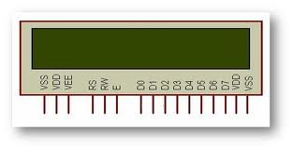**

LCD 16x2 Display

**LCD (Liquid Crystal Display**): A 16x2 LCD display is very basic module and is very commonly used in various devices and circuits. These modules are preferred over [seven segments](http://www.engineersgarage.com/content/seven-segment-display) and other multi segment [LED](http://www.engineersgarage.com/content/led)s. The reasons being: LCDs are economical; easily programmable; have no limitation of displaying special & even [custom characters](http://www.engineersgarage.com/microcontroller/8051projects/create-custom-characters-LCD-AT89C51) (unlike in seven segments) [animations](http://www.engineersgarage.com/microcontroller/8051projects/display-custom-animations-LCD-AT89C51) and so on.

A **16x2 LCD** means it can display 16 characters per line and there are 2 such lines. In this LCD each character is displayed in 5x7 pixel matrix. This LCD has two registers, namely, Command and Data.

The command register stores the command instructions given to the LCD. A command is an instruction given to LCD to do a predefined task like initializing it, clearing its screen, setting the cursor position, controlling display etc. The data register stores the data to be displayed on the LCD. The data is the ASCII value of the character to be displayed on the LCD. Click to learn more about internal structure of a [LCD](http://www.engineersgarage.com/insight/how-lcd-works).

## 

## Pin Description:

|  |  |  |
| --- | --- | --- |
| **Pin No** | **Function** | **Name** |
| 1 | Ground (0V) | Ground |
| 2 | Supply voltage; 5V (4.7V – 5.3V) | Vcc |
| 3 | Contrast adjustment; through a variable resistor | VEE |
| 4 | Selects command register when low; and data register when high | Register Select |
| 5 | Low to write to the register; High to read from the register | Read/write |
| 6 | Sends data to data pins when a high to low pulse is given | Enable |
| 7 | 8-bit data pins | DB0 |
| 8 | DB1 |
| 9 | DB2 |
| 10 | DB3 |
| 11 | DB4 |
| 12 | DB5 |
| 13 | DB6 |
| 14 | DB7 |
| 15 | Backlight VCC (5V) | Led+ |
| 16 | Backlight Ground (0V) | Led- |

Pin description of LCD 16x2 Display

## OPTO-COUPLER:

**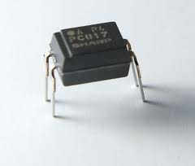**

Opto-Coupler IC

The PC-817 contains a light emitting diode optically coupled to a phototransistor. It is packaged in a 4-pin DIP package and available in wide-lead spacing option and lead bend SMD option. Input-output isolation voltage is 5000 Vrms. Response time, tr, is typically 4 µs and minimum CTR is 50% at input current of 5 mA.

**`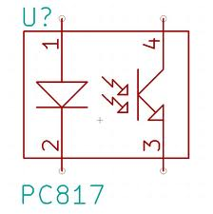 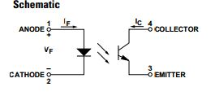**

Internal connection and schematic of Opto-Coupler IC PC817

## DC-12V RELAY:

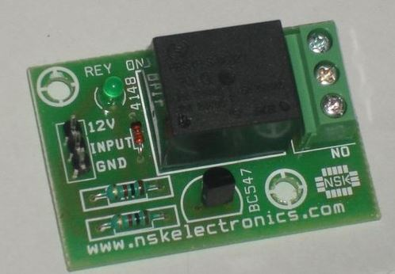

Relay

A relay is an electrical switch that uses an electromagnet to move the switch from the off to on position instead of a person moving the switch. It takes a relatively small amount of power to turn on a relay but the relay can control something that draws much more power.

## **OPERATION OF RELAY:**

Relays (and switches) come in different configurations. The most common are shown to the right. Single Pole Single Throw (SPST) is the simplest with only two contacts. Single Pole Double Throw (SPDT) has three contacts. The contacts are usually labelled Common (COM), Normally Open (NO), and Normally Closed (NC). The Normally Closed contact will be connected to the Common contact when no power is applied to the coil. The Normally Open contact will be open (i.e. not connected) when no power is applied to the coil. When the coil is energized the Common is connected to the Normally Open contact and the Normally Closed contact is left floating. The Double Pole versions are the same as the Single Pole version except there are two switches that open and close together. Select a relay with contacts that can handle the voltage and current requirements of the load. Keep in mind that some loads (such as motors) draw much more current when first turned on than they do at steady state. Select a relay with a coil voltage and current that you can control easily. Ex: If you want to turn on the AC unit with a 12VDC power supply get a 12VDC coil. Note: Coils will be rated for either AC or DC.

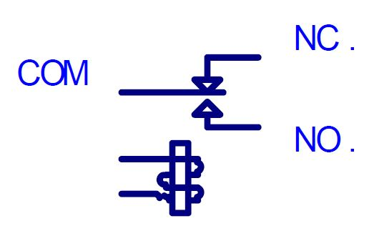

Relay Operation

## The primary functions of a relay are:

* The galvanic separation of the primary or actuating circuit and the load circuits
* Single input/multiple output capability
* Separation of different load circuits for multi-pole relays
* Separation of AC and DC circuits
* Interface between electronic and power circuits
* Multiple switching functions, e.g. delay, signal conditioning
* Amplifier function.

## Applications of Relay:

Typical applications for relays include laboratory instruments, telecommunication systems, computer interfaces, domestic appliances, air conditioning and heating, automotive electrics, traffic control, lighting control, building control, electric power control, business machines, control of motors and solenoids, tooling machines, production and test equipment.

**TARANG F4 ZIGBEE MODULE:**

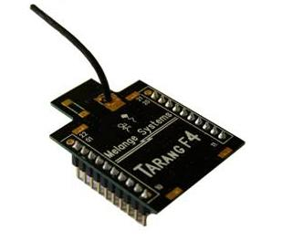

**MELANGE TANRANG F4 ZIGBEE MODULE**

ZigBee is a low-cost, low-power, wireless mesh network standard. The low cost allows the technology to be widely deployed in wireless control and monitoring applications. Low power usage allows longer life with smaller batteries. Mesh networking provides high reliability and more extensive range. ZigBee chip vendors typically sell integrated radios.

The ZigBee network layer natively supports both star and tree typical networks, and generic mesh networks. Every network must have one coordinator device, tasked with its creation, the control of its parameters and basic maintenance. Within star networks, the coordinator must be the central node. Both trees and meshes allows the use of ZigBee routers to extend communication at the network level.

## Features and Benefits:

* Point to point, point to multi point, Mesh and peer-to-peer topologies on proprietary stack.
* Direct Sequence Spread Spectrum technology.
* Each direct sequence channel has 64K unique network addresses.
* Transmit Power: 0 dBs
* RF data rate: 250 kbps.
* Acknowledgement mode communication with retries.
* Power saving modes.
* Source / destination addressing.
* Unicast and broadcast communication.
* Analog to digital conversion and digital I/O line support.
* Default configuration for ready to use.

## Specifications:

# Power

|  |  |
| --- | --- |
| Supply Voltage | 3.3 to 3.6V |
| Transmit Current | 45mA |
| Idle/Receive Current | 50mA |
| Power-down Current | <10 µA |

# General

|  |  |
| --- | --- |
| Rating Frequency | ISM 2.4 - 2.4835 GHz |
| Maximum Transmit Power Output | 1mW (+0 dBm) |
| RF Data Rate | 250 kbps |
| Receiver Sensitivity | -92 dBm |
| Serial Interface Data Rate | Up to 115200 baud |
| Operating Temperature | -40 to 85 °C |
| Antenna Options | Chip Antenna, Wire Antenna |
| Antenna Connector | MMCX |

# Network

|  |  |
| --- | --- |
| Supported Network Topologies | Peer-to-peer, point to multipoint & Mesh |
| Number Of Channels | 16 direct sequence channels |
| Addressing Options | PAN ID, Channel and addresses |

# Mechanical

|  |  |
| --- | --- |
| Dimensions | 37mm x 26mm. |
| Interface Connector | 20 pin receptacles, 2.00mm pitch. |

A Wireless Distributed Network (WSN) has distributed[**autonomous**](http://en.wikipedia.org/wiki/Autonomous)[**sensors**](http://en.wikipedia.org/wiki/Sensor)tomonitorphysical or environmental conditions, such astemperature, sound,[**pressure**](http://en.wikipedia.org/wiki/Pressure), etc. and to cooperatively pass their data through the network to a main location. The WSN is built of "nodes" – from a few to several hundreds or even thousands, where each node is connected to one (or sometimes several) sensors.

ZigBee based wireless sensor networks have tremendous usage potential, because they are much more flexible in both installation and running operation mode than conventional wired networks. ZigBee wireless networks are adaptive and self-healing, that means these networks can withstand even hostile changes in the environment, like devices leaving the network due to hardware malfunctions or electromagnetic interferences. The ZigBee specification puts very much emphasis on battery power conservation all the layers (physical, Media Access Control (MAC), network and application) from the ground up (IEEE 802.15.4) support this most important goal. The standard specifies that a ZigBee End Device (ZED) must be able to operate at a minimum for 2 years on a single battery cell. [1] The transmission is low data rate, that means that while the maximum theoretical throughput between two devices can be up to around 250 kbps.

## SIM900 GSM MODULE:

You need only two wires (TX, RX) except Power supply to interface with microcontroller / Arduino. The built in Power supply allows you to connect wide range unregulated power supply. Using this modem, you can send SMS, data and read SMS through simple AT command.

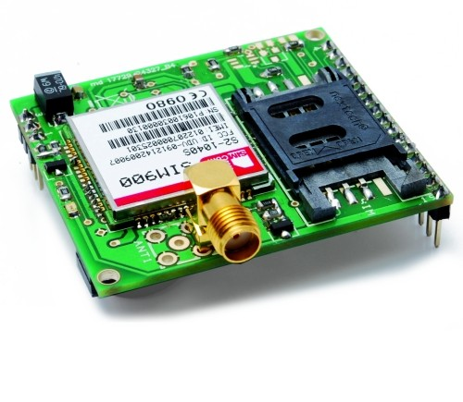

SIM900 GSM MODULE

This is a complete Quad-band GSM/GPRS module in a SMT type and designed with a very powerful single-chip processor integrating AMR926EJ-S core, allowing you to benefit from small dimensions and cost-effective solutions.

Featuring an industry-standard interface, the SIM900 delivers GSM/GPRS 850/900/1800/1900MHz performance for voice, SMS, Data, and Fax in a small form factor and with low power consumption. With a tiny configuration of 24mm x 24mm x 3 mm, SIM900 can fit almost all the space requirements in your M2M applications, especially for slim and compact demands of design.

## 

**REAL TIME CLOCK:**

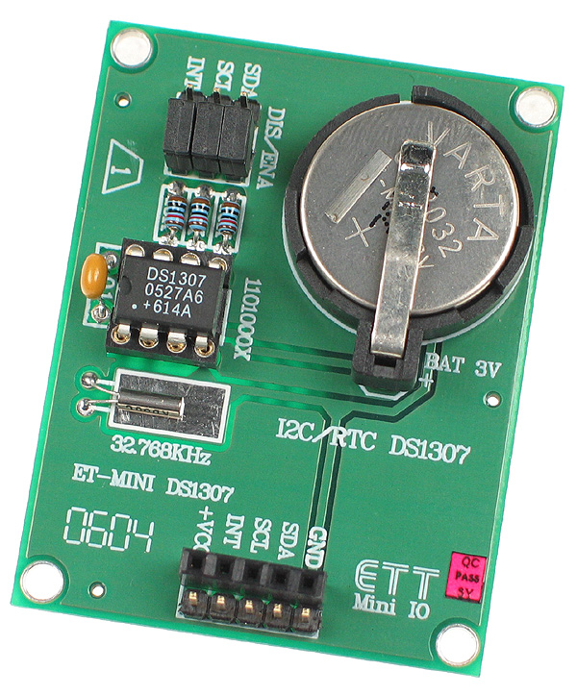

**REAL TIME CLOCK**

A **real-time clock** (**RTC**) is a [computer](http://en.wikipedia.org/wiki/Computer) [clock](http://en.wikipedia.org/wiki/Clock) (most often in the form of an [integrated circuit](http://en.wikipedia.org/wiki/Integrated_circuit)) thatkeeps track of the current [time](http://en.wikipedia.org/wiki/Time). Although the term often refers to the devices in [personal computers](http://en.wikipedia.org/wiki/Personal_computer), [servers](http://en.wikipedia.org/wiki/Server_(computing)) and [embedded systems](http://en.wikipedia.org/wiki/Embedded_system), RTCs are present in almost any electronic device which needs to keep accurate time.

RTCs often have an alternate source of power, so they can continue to keep time while the primary source of power is off or unavailable. This alternate source of power is normally a [lithium battery](http://en.wikipedia.org/wiki/Lithium_battery) in older systems, but some newer systems use a [supercapacitor](http://en.wikipedia.org/wiki/Supercapacitor" \o "Supercapacitor)because they are rechargeable and can be [soldered](http://en.wikipedia.org/wiki/Soldering). The alternate power source can also supply power to [battery backed RAM](http://en.wikipedia.org/wiki/Nonvolatile_BIOS_memory).

Most RTCs use a [crystal oscillator](http://en.wikipedia.org/wiki/Crystal_oscillator) but some use the [power line frequency](http://en.wikipedia.org/wiki/Utility_frequency).In many cases the oscillator's frequency is 32.768 kHz. This is the same frequency used in[quartz clocks and watches](http://en.wikipedia.org/wiki/Quartz_clock), and for the same reasons, namely that the frequency is exactly 215 cycles per second, which is a convenient rate to use with simple binary counter circuits.

**Purpose:**

* Low power consumption (important when running from alternate power)
* Frees the main system for time-critical tasks
* Sometimes more accurate than other methods

**USB FLASH DRIVE CONNECTIVITY:**

**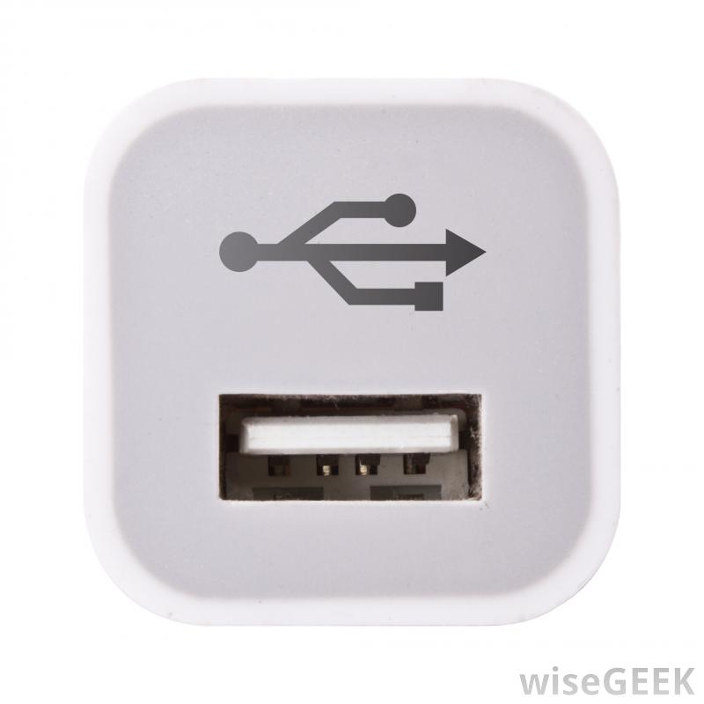 **

**USB FEMALE PORT USB FLASH DRIVE**

A **USB flash drive** is a [data storage device](http://en.wikipedia.org/wiki/Data_storage_device) that includes [flash memory](http://en.wikipedia.org/wiki/Flash_memory) with an integrated [Universal Serial Bus](http://en.wikipedia.org/wiki/Universal_Serial_Bus) (USB) interface. USB flash drives are typically removable and rewritable, and physically much smaller than an [optical disc](http://en.wikipedia.org/wiki/Optical_disc). Most weigh less than 30 grams (1.1 oz). Storage capacities as large as 2 TB are planned, with steady improvements in size and price per capacity expected.[[4]](http://en.wikipedia.org/wiki/USB_flash_drive#cite_note-PCworld_239260-4) Some allow up to 100,000 write/erase cycles, depending on the exact type of memory chip used, and a 10-year [shelf storage time](http://en.wikipedia.org/wiki/Digital_permanence).They are smaller, faster, have thousands of times more capacity, and are more durable and reliable because they have no[moving parts](http://en.wikipedia.org/wiki/Moving_parts). Additionally, they are immune to magnetic interference (unlike floppy disks), and unharmed by surface scratches (unlike CDs). USB flash drives use the [USB mass storage](http://en.wikipedia.org/wiki/USB_mass_storage_device_class) standard, supported natively by modern [operating systems](http://en.wikipedia.org/wiki/Operating_system) such as [Linux](http://en.wikipedia.org/wiki/Linux), [OS X](http://en.wikipedia.org/wiki/OS_X), [Windows](http://en.wikipedia.org/wiki/Microsoft_Windows), and other [Unix-like](http://en.wikipedia.org/wiki/Unix-like) systems, as well as many [BIOS](http://en.wikipedia.org/wiki/BIOS) boot ROMs. USB drives with USB 2.0 support can store more data and transfer faster than much larger [optical disc drives](http://en.wikipedia.org/wiki/Optical_disc_drive).

A flash drive consists of a small [printed circuit board](http://en.wikipedia.org/wiki/Printed_circuit_board) carrying the circuit elements and a USB connector, insulated electrically and protected inside a plastic, metal, or rubberized case which can be carried in a pocket or on a key chain, for example. The USB connector may be protected by a removable cap or by retracting into the body of the drive, although it is not likely to be damaged if unprotected. Most flash drives use a standard [type-A USB connection](http://en.wikipedia.org/wiki/Universal_Serial_Bus) allowing connection with a port on a personal computer, but [drives for other interfaces](http://en.wikipedia.org/wiki/USB_flash_drive#Flash_drives_for_non-USB_interfaces) also exist. USB flash drives draw power from the computer via the USB connection.

**Essential Components in an USB:**

* Standard-A USB plug – provides a physical interface to the host computer.
* USB mass storage controller – a small [microcontroller](http://en.wikipedia.org/wiki/Microcontroller) with a small amount of on-chip [ROM](http://en.wikipedia.org/wiki/Read-only_memory) and [RAM](http://en.wikipedia.org/wiki/Random_Access_Memory).
* [NAND flash](http://en.wikipedia.org/wiki/NAND_flash) memory chip(s) – stores data (NAND flash is typically also used in [digital cameras](http://en.wikipedia.org/wiki/Digital_camera)).
* [Crystal oscillator](http://en.wikipedia.org/wiki/Crystal_oscillator) – produces the device's main 12 MHz [clock signal](http://en.wikipedia.org/wiki/Clock_signal) and controls the device's data output through a [phase-locked loop](http://en.wikipedia.org/wiki/Phase-locked_loop).
* Cover - typically made of plastic or metal - to protect the electronics against mechanical stress and even possible short circuits

**SOLAR ENERGY HARVESTING:**

**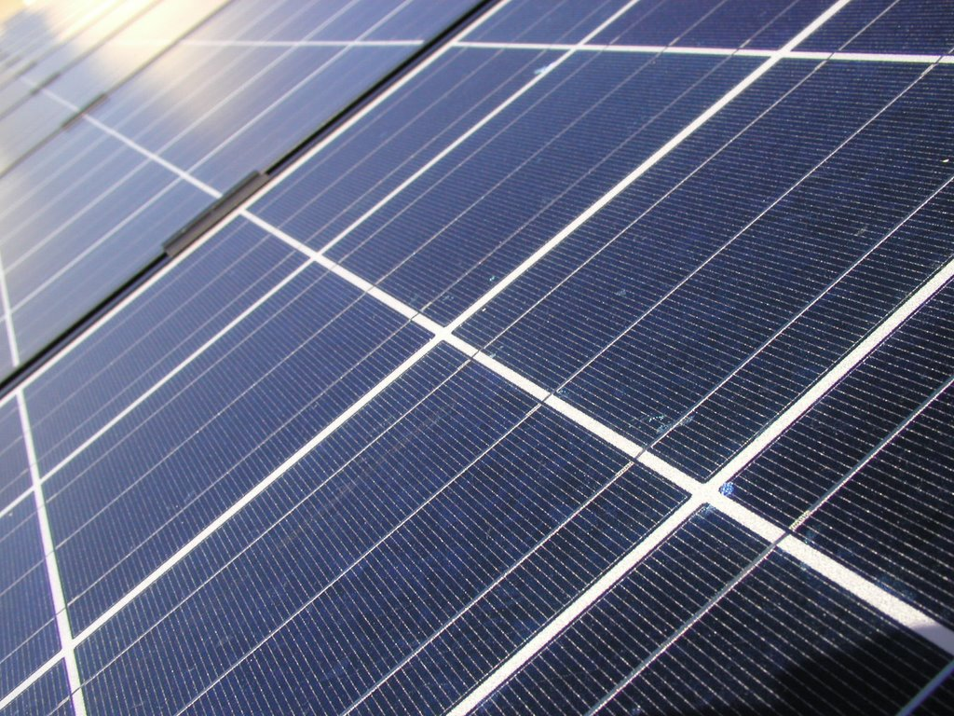**

**SOLAR PANEL**

**Solar energy**, radiant [light](http://en.wikipedia.org/wiki/Light) and [heat](http://en.wikipedia.org/wiki/Heat) from the [sun](http://en.wikipedia.org/wiki/Sun), is harnessed using a range of ever-evolvingtechnologies such as [solar heating](http://en.wikipedia.org/wiki/Solar_heating), [solar photovoltaics](http://en.wikipedia.org/wiki/Solar_photovoltaics), [solar thermal electricity](http://en.wikipedia.org/wiki/Solar_thermal_electricity), [solar architecture](http://en.wikipedia.org/wiki/Solar_architecture) and [artificial photosynthesis](http://en.wikipedia.org/wiki/Artificial_photosynthesis).

Solar technologies are broadly characterized as either [passive solar](http://en.wikipedia.org/wiki/Passive_solar) or [active solar](http://en.wikipedia.org/wiki/Active_solar) depending on the way they capture, convert and distribute solar energy. Active solar techniques include the use of photovoltaic panels and [solar thermal](http://en.wikipedia.org/wiki/Solar_thermal_energy) collectors to harness the energy. Passive solar techniques include orienting a building to the Sun, selecting materials with favorable[thermal mass](http://en.wikipedia.org/wiki/Thermal_mass) or light dispersing properties, and designing spaces that [naturally circulate air](http://en.wikipedia.org/wiki/Ventilation_(architecture)).

The Earth receives 174 [petawatts](http://en.wikipedia.org/wiki/Orders_of_magnitude_(power)" \l "petawatt_.281015_watts.29" \o "Orders of magnitude (power)) (PW) of incoming solar radiation ([insolation](http://en.wikipedia.org/wiki/Insolation)) at the upper [atmosphere](http://en.wikipedia.org/wiki/Earth%27s_atmosphere). Approximately 30% is reflected back to space while the rest is absorbed by clouds, oceans and land masses. The [spectrum](http://en.wikipedia.org/wiki/Electromagnetic_spectrum) of solar light at the Earth's surface is mostly spread across the [visible](http://en.wikipedia.org/wiki/Visible_light) and [near-infrared](http://en.wikipedia.org/wiki/Near-infrared) ranges with a small part in the [near-ultraviolet](http://en.wikipedia.org/wiki/Near-ultraviolet). Solar energy can be harnessed at different levels around the world, mostly depending on distance from the equator.

|  |
| --- |
| **Yearly Solar fluxes & Human Energy Consumption** |
| Solar | 3,850,000 [EJ](http://en.wikipedia.org/wiki/Joule#Multiples)[[8]](http://en.wikipedia.org/wiki/Solar_energy#cite_note-Smil_2006.2C_p._12-8) |
| Wind | 2,250 EJ[[9]](http://en.wikipedia.org/wiki/Solar_energy#cite_note-9) |
| Biomass potential | 100–300 EJ[[10]](http://en.wikipedia.org/wiki/Solar_energy#cite_note-fa.upc.es-10) |
| Primary energy use (2010) | 539 EJ[[11]](http://en.wikipedia.org/wiki/Solar_energy#cite_note-11) |
| Electricity (2010) | 66.5 EJ[[12]](http://en.wikipedia.org/wiki/Solar_energy#cite_note-12) |

The project employs the benefits of solar energy harvesting once the input supply specifications are finalized. Using solar energy optimizes the circuit functions further more since the input supply power is minized as far as possible. Also this brings a certain value to the project.